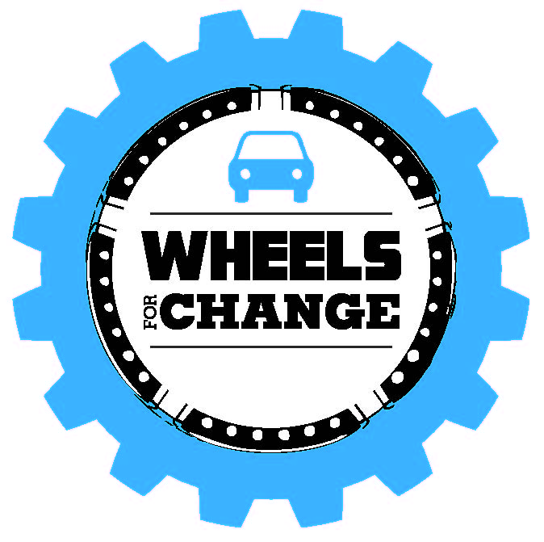
Grant Reporting

It is crucial that the mission and goals of Wheels for Good are being met and that our partnering organizations are benefiting from the collaboration.

As a condition of receiving a grant, your organization is required to provide Wheels for Good with formal feedback on the program six months after taking receipt of the vehicle. Your organization’s input will enable us to strengthen our mission and vision as well as adjust program guidelines, expand consulting and educational services, and grow and develop the Foundation overall.

I. Executive Summary
In three to five paragraphs, highlight the major accomplishments of the grant. Include the reporting period dates and details on tangible outcomes and lessons learned.

II. Grant Outcomes
The following outline is a guide to the information to be provided in the post-grant report narrative. Use the format as appropriate for your organization.

A. Outcomes Achieved
- Briefly summarize the purpose of the partnership with Wheels for Good (vehicle funding, technical support, training, etc.) and the issue or need that was addressed.
- Summarize the anticipated results and the degree to which they were achieved to date. Provide quantitative and/or qualitative evidence that measures the success of the grant activities.

B. Lessons Learned and Evaluation of Wheels for Good
- Describe any lessons learned regarding the implementation, scope of activities, collaborating with Wheels for Good personnel, measuring results, or other factors.
- What recommendations do you have for Wheels for Good to maximize the impact of our funding in this area or better support grantees?
- Evaluate the overall process from completing the application to consulting, to vehicle purchase and delivery, and on-going support.

Optional: You may include press releases, recent newspaper/magazine articles, photographs, brochures, or other materials highlighting the grant-funded activities and accomplishments.

Submit completed reporting form to Deb Feinberg by email at dfeinberg@mileone.com or by mail to
Wheels for Good, 1 Olympic Place, Suite 1200, Towson, MD 21204

